Analysis Model Document for +Health Page 1

Analysis Model Document

for

+Health

Version 1.0 Approved

Prepared by:

Cindy Torres

Ricardo Luna

Giovanni Guzmán

09/27/19
Analysis Model Document for +Health Page 2

Revision History


Date Version Description Author

Ricardo Luna

09/27/2019 1.0 Analysis Model Document 1.0 Cindy Torres
Giovanni Guzmán
Analysis Model Document for +Health Page 3

Table of Contents
- Introduction 4
  - Purpose 4
  - Scope 4
  - Definitions, Acronyms and Abbreviations 4
  - References 5
  - Overview 5
- Overall Description 5
- Robustness Diagrams 6
  - Create an Account 7
  - View Patient’s Medical History 8
  - Create Patient’s Diagnosis 9
  - Create Patient’s Treatment 10
  - Upload Medical Studies 11
Analysis Model Document for +Health Page 4

1 Introduction

An Analysis Model Document is the description of a software that shows the objects that participate in the scenario and how those objects interact which each other. It is modeled after the software requirements specification. Analysis Model operates as a link between the ‘system description’ and the ‘design model’. In the analysis model, information, functions and the behavior of the system is defined and these are translated into the architecture, interface and component level design in the ‘design modelling’.

The aim of this document is to provide the first ‘technical’ representation of the system, and to deal with the problem by partitioning the system.

1.1 Purpose

The purposes of the Analysis Model are specifying the software’s operational characteristics, indicating the software’s interfaces with other system elements, establishing constraints that the software must meet, providing the software designer with a representation of information, function and behavior, and providing the developer and customer with the means to assess quality once the software is built.

1.2 Scope

The purpose of +Health is to ease patients’ medical information management and to create a convenient and easy-to-use application for doctors, trying to have all their patients’ medical information in a handy way. Above all, it is expected for the application to provide a comfortable user experience.

1.3 Definitions, Acronyms and Abbreviations

- Patient’s Medical Information: Medical general information of the patient such as height, weight, chronic diseases and clinical information.
Analysis Model Document for +Health Page 5

- Patient’s Medical History: Data related to a person’s medical history, including symptoms, diagnoses, procedures, and outcomes. It also includes patient histories, lab results, x-rays, and so on.

- Patient’s Code. Unique identifier that the system assigns to a patient.

1.4 References

Software Requirements Specification. (2019). 2nd ed. +Health.

1.5 Overview

The remaining sections of this document describes what the customer requires, establishes a basis for the creation of a software design, and defines a set of requirements that can be validated once the software is built. All elements of this analysis model are directly traceable to parts of the design model, and some parts overlap.

2 Overall Description

What is +Health? +Health is an application that pretends to gather all the patients’ medical information such as chronic diseases, medical analysis, prescriptions, treatments, diagnoses and operations.

+Health purpose is to eliminate the lack of information of a patient on their medical history by having a centralized system that: 1) is able to access medical information at any given moment. 2) give access to a third party when needed. It will give a much wider and concrete insight on a patient (speaking in medical terms).

The patient will be able to access any of their medical diagnoses and treatments, mitigating misunderstandings between the parties involved. This will also improve the verification of a diagnoses and treatments from a third party, since all the information will be presented directly through the system.
Having a centralized system with all the medical history of a patient will keep misinterpretations to a minimum.
Analysis Model Document for +Health Page 6

3 Robustness Diagrams

Robustness diagrams allow to visually represent the relation between entities, controls, boundaries and actors. It uses graphical as follows:
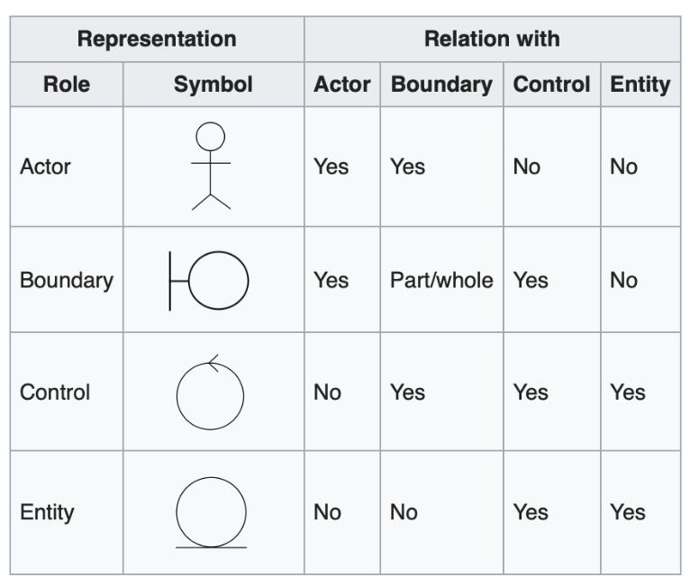

The following are the robustness diagrams constraints:

- Actors may only know and communicate with boundaries.

- Boundaries may communicate with actors and controls only.

- Controls may know and communicate with boundaries and entities, and if needed other controls.

- Entities may only know about other entities but could communicate

also with controls.

The Robustness Analysis involves analyzing the narrative text of use cases, identifying a first-guess set of objects that participate in those use cases and classifying the objects based on the roles they play.
Analysis Model Document for +Health Page 7

3.1 Create an Account
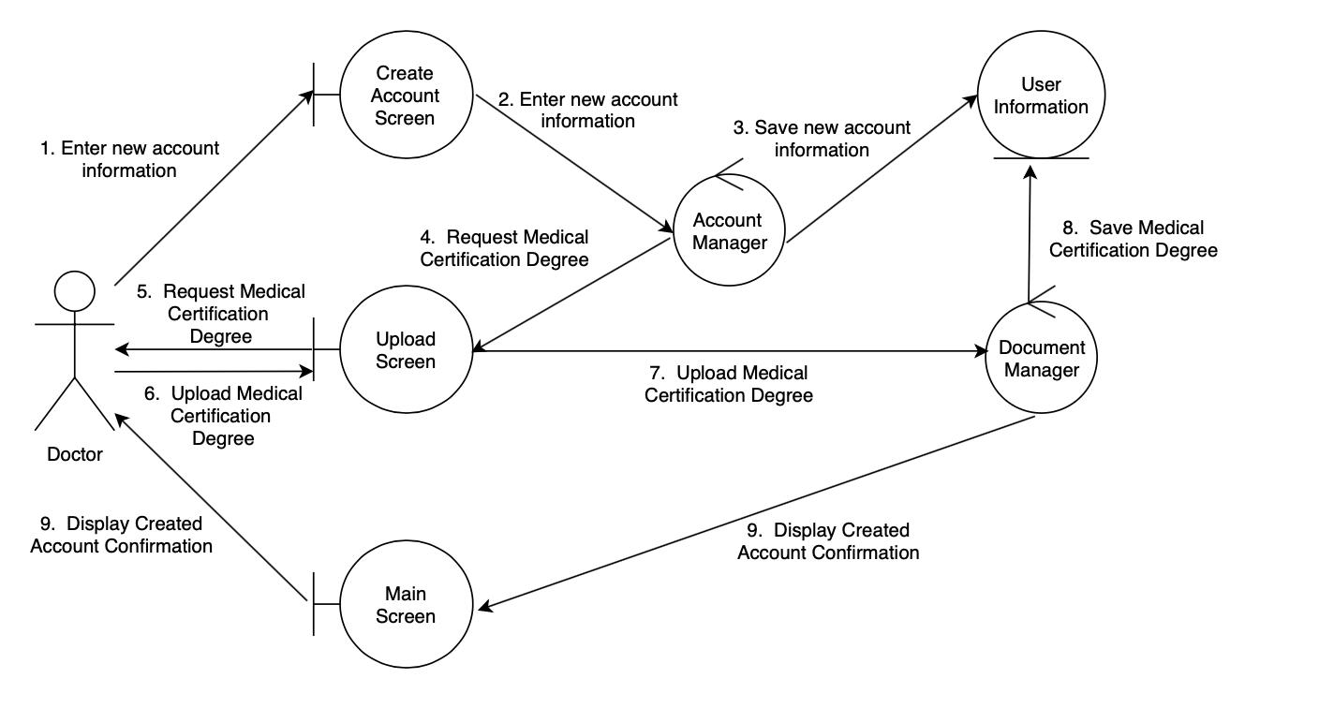

Steps:

- The doctor selects “Create an account”.

- The system asks for their account information such as name, email and password, and also for their personal information such as full name, age, sex, college career, medical speciality and years of experience.

- The doctor enters the data and selects “Continue”.

- The system validates the doctor’s information by checking if all the corresponding fields are correctly filled.
- The system asks for a Medical Certification Degree.

- The doctor shall upload their Medical Certification Degree (a document that shows their permission to work as a doctor).

- The system validates the doctor’s Medical Certification Degree by checking if a document is attached.
- The doctor’s information is stored in their account.

- The system shows the message “Account created successfully”.
Analysis Model Document for +Health Page 8

3.2 View Patient’s Medical History
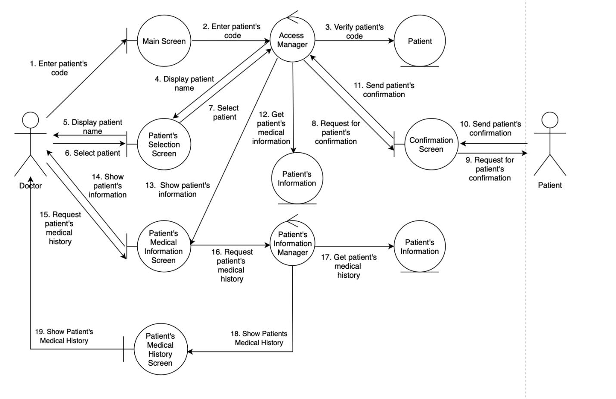

Steps:

- The doctor enters the patient code in order to access to their medical history.

- The system shall validate that the patient’s code exists.

- The system retrieves the patient.

- The doctor should check that it is the correct patient and then select “Show patient’s information”.
- The patient shall give access to their information to their doctor.

- The system retrieves the patient’s general information and shows it to the doctor.
- The doctor selects “View patient’s medical history”.

- The system retrieves the Patient’s Medical History.
Analysis Model Document for +Health Page 9

3.3 Create Patient’s Diagnosis
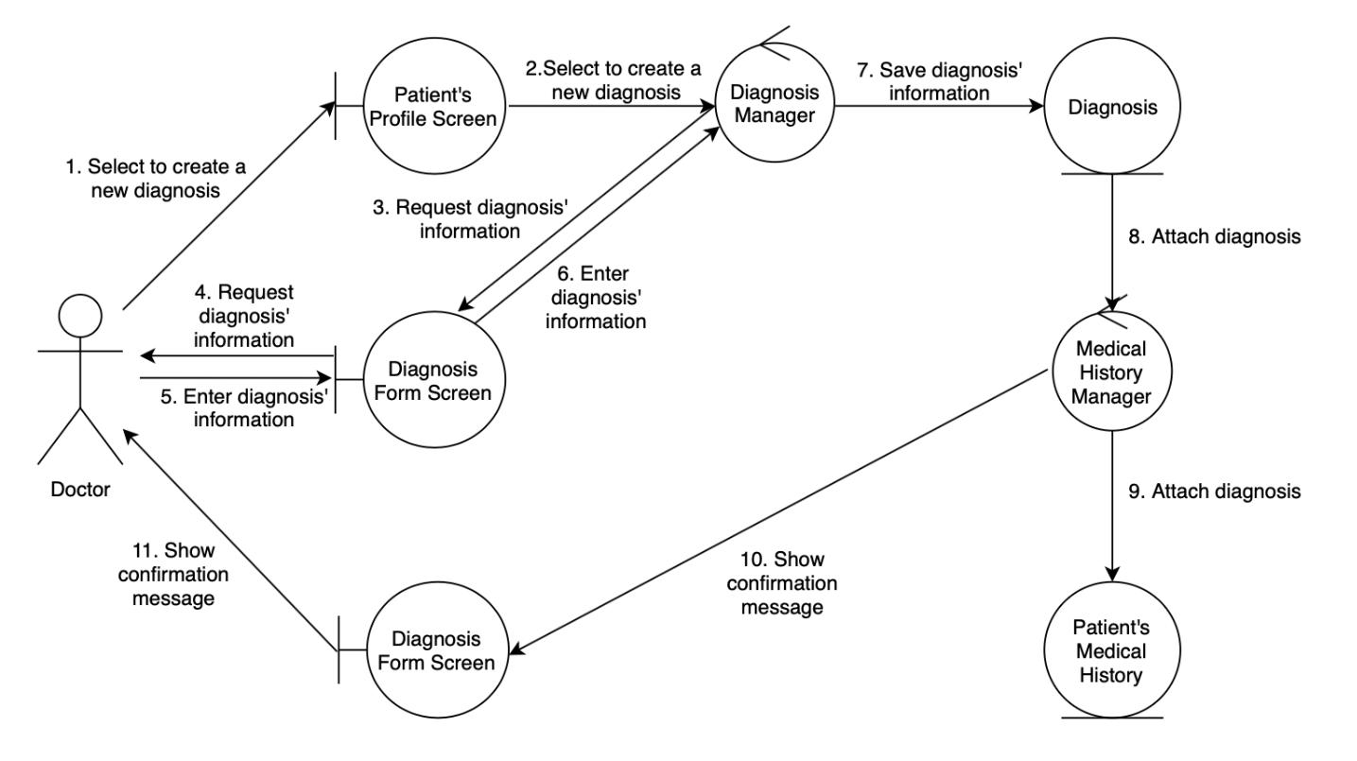

Steps:

- This use case starts when the doctor selects “New diagnosis” in the patient’s profile.

- The system asks for diagnosis information. This information refers to date, general observations and the patient’s diagnosis.
- The doctor enters the diagnosis information and selects “Add diagnosis”.

- The system validates the entered information by checking if all the corresponding fields are correctly filled.

- The system attaches the diagnosis’ information to the patient’s medical history and shows the message “Diagnosis created”.
Analysis Model Document for +Health Page 10

3.4 Create Patient’s Treatment
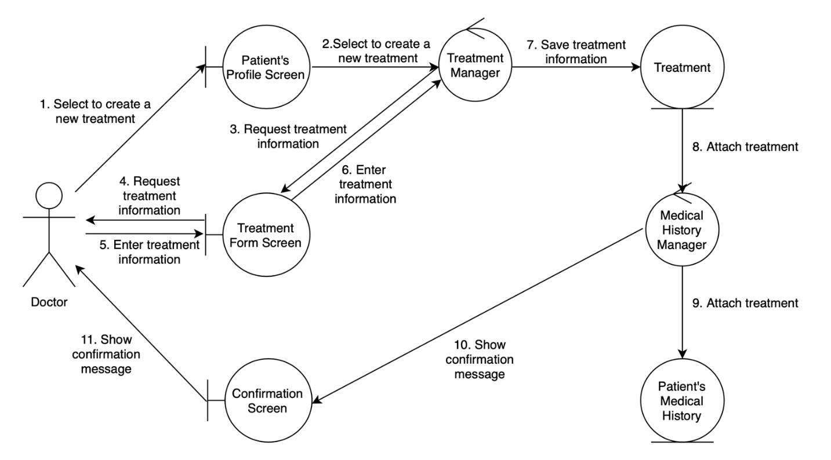

Steps:

- The doctor selects “New treatment prescription” in the patient’s profile.

- The system asks for prescription’s information. This information refers to date, list of drugs, medicine notes and general observations.

- The doctor enters the prescription information and selects “Add prescription”.

- The system validates the entered information by checking if all the corresponding fields are correctly filled.
- The system attaches the prescription’s information to the patient’s medical history and shows the message “Prescription created”.
Analysis Model Document for +Health Page 11

3.5 Upload Medical Studies
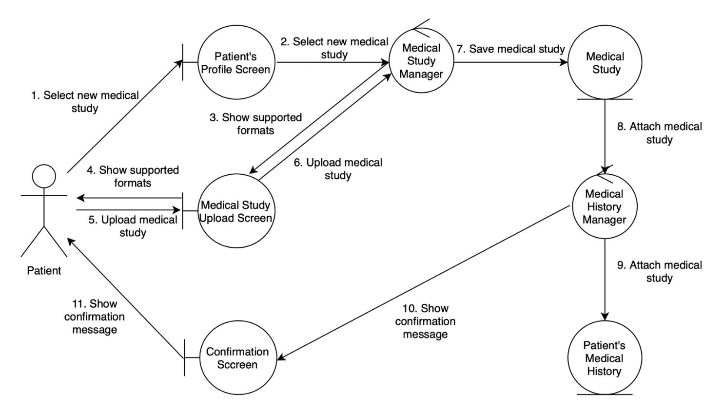

Steps:

- This use case starts when the patient selects “Upload medical study” in their profile.

- The system shows to the patient the supported formats to upload their medical study.
- The patient is able to choose the medical study that wants to upload.

- The patient selects “Confirm”.

- The system validates the uploaded document by checking if it is in a supported format.
- The system attaches the uploaded study to the patient’s medical history and shows the message “Prescription created”.

